ASSIGNMENT -III
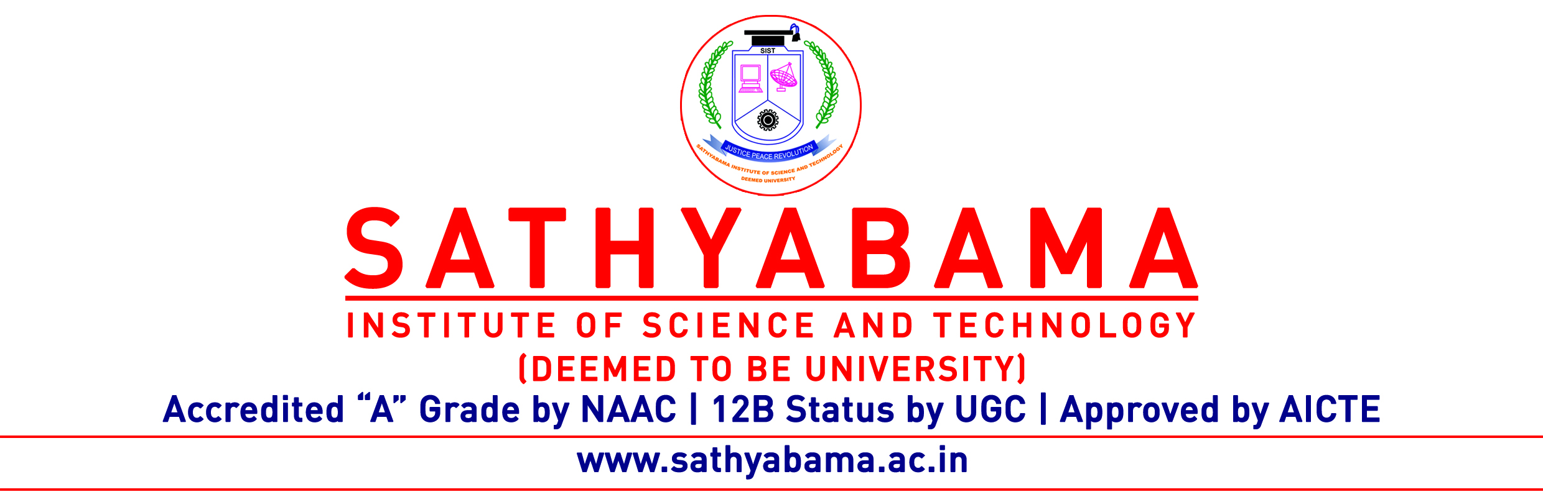
Program : B.Tech-IT Max. Marks : 15
Course : Data Communications & Computer Networks Sem : V
Course code : SCS1314 Batch : 2018-2022

Fill in Blanks (5x1=5)
- The packet of information at the application layer is called __________
- Application layer offers _______ service
- The first line of HTTP request message is called _____________
- When displaying a web page, the application layer uses the _____________ protocol
- SNMP is the framework for managing devices in an internet using the ______ protocol
Short Answers (5x1=5)
- List the types of Hub
- What is a bridge
- List out the features of HTTP
- State the four parts of URL
- Differentiate FTP and HTTP

Long Answer (1x 5=5)
11. Draw and explain the functions DNS

